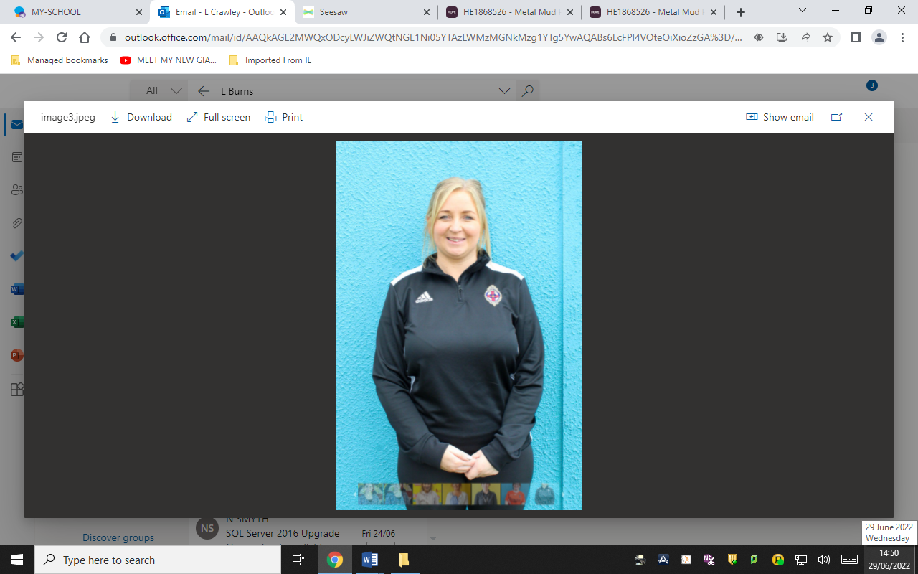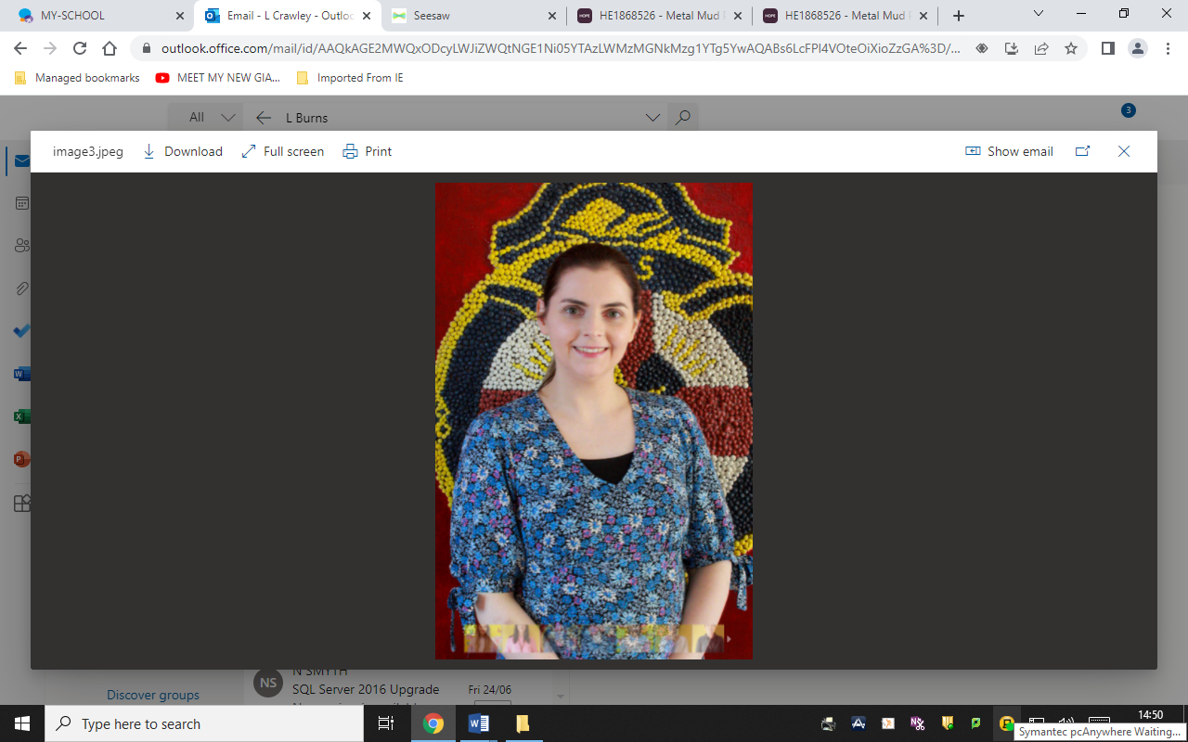

Christian Brothers’ P.S. Armagh

Safeguarding Team

**Mrs L McAuley**

**Child Protection Designated Teacher**

**Mrs A Fay**

**Child Protection Designated Teacher**

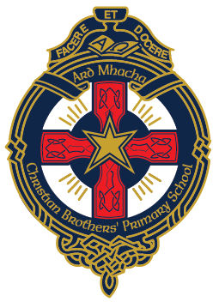

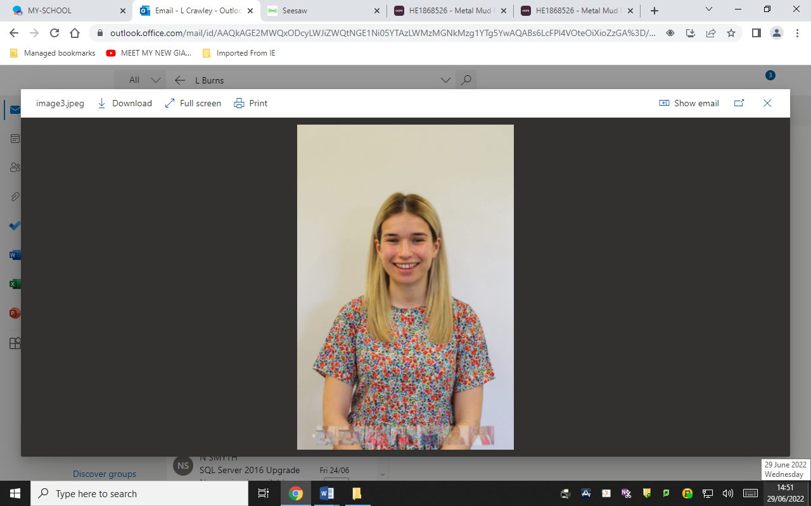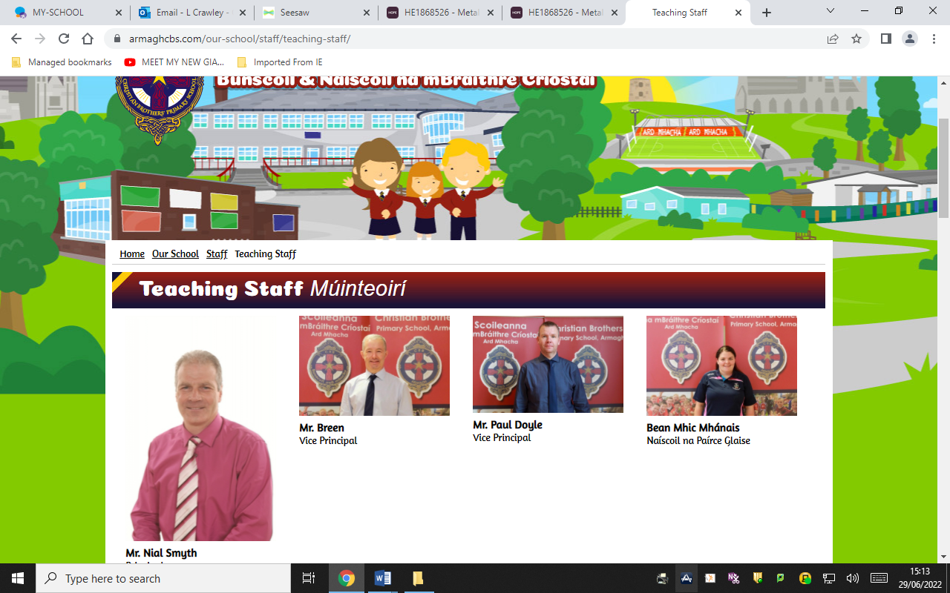

**Miss S Breen**

**Child Protection Deputy**

**Designated Teacher**

**Mr P Doyle**

**Principal**